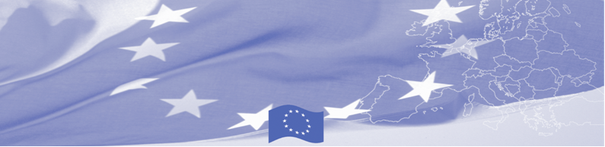
PRESS RELEASE

For release on June 14, 2016

BOMCA welcomes Central Asian partners in Latvia

In the framework of BOMCA Programme, financed by the European Union, a study visit will be held in Latvia between 14 and 16 June 2016. Hosted by Latvian State Border Guard, this 3-day visit will focus on legal and procedural instruments to manage both regular and irregular migration flows at borders. It will gather 20 officials from border, customs, migration, veterinary and phytosanitary agencies from 5 Central Asian countries – Kazakhstan, Kyrgyzstan, Tajikistan, Turkmenistan and Uzbekistan.

This BOMCA activity is intended to present EU good practices and examples of EU external borders. Modern approaches in the field of border security, document security, biometrics, practical border checks and management of the legal migration will be presented to participants as well as organizational structure and personnel policy that are in place in EU Border, Customs and Veterinary and Phytosanitary agencies. Also, such important issue as cooperation and information exchange at intra-agency, inter-agency, regional and international levels among CA border agencies will be discussed and advantages will be presented to delegates.

First BOMCA operations began in Central Asia in 2003, and since then, BOMCA has strengthened partnership of the Central Asia Governments in the field of border management. The European Union allocated a sum of EUR 33.6 million to BOMCA for the period of 2003 – 2014 and almost EUR 5 million for its 9th implementation phase (2015 - 2018).

For more information please contact BOMCA office in Kyrgyzstan – +996 312394071 or janna.tashieva@icmpd.org

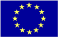  The Programme is imple-mented by the Consortium of partners led by the State Border Guard of the Republic of Latvia:  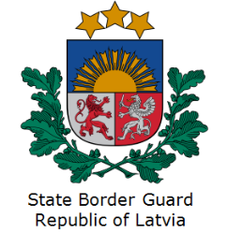 | This Programme is funded by the European Union  Delegation of the European Union to the Kyrgyz Republic  21 Erkindik Boulevard, Business Centre Orion, 5th floor  Bishkek, 720040, Kyrgyz Republic  Telephone: +996 312 26 10 00  Fax: +996 312 26 10 07  E-mail: delegation-kyrgyzstan@eeas.europa.eu  Website:http://eeas.europa.eu/delegations/  kyrgyzstan  Facebook:http://www.facebook.com/eudelkg | The European Union is made up of 28 Member States who have decided to gradually link together their know-how, resources and destinies. Together, during a period of enlargement of 60 years, they have built a zone of stability, democracy and sustainable development whilst maintaining cultural diversity, tolerance and individual freedoms. The European Union is committed to sharing its achievements and its values with countries and peoples beyond its borders.

