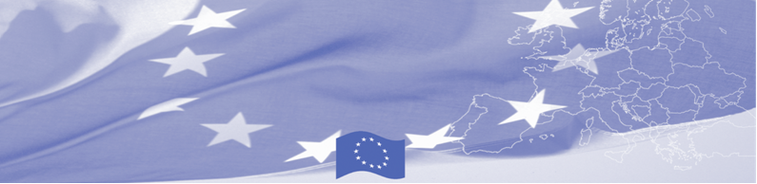
PRESS RELEASE

For release on 07 June 2016

BOMCA technical assistance mission on IBM visits Kyrgyzstan

The EU is continuing to offer significant support to border security strategic planning in Central Asia. Thus, a technical assistance mission on implementation of certain chapters of National Strategy of Integrated Border Management 2012-2022 in Kyrgyzstan (IBM Strategy 2012-2022) starts in Bishkek on June 07th, 2016 within the framework of Border Management Programme in Central Asia (BOMCA). The mission envisages a series of meetings between the European Union experts from the Republic of Latvia and main IBM actors in Kyrgyzstan, including the Government Office, State Border Service, State Customs Service and other ministries and agencies involved in border management in Kyrgyzstan.

The key objective of the technical assistance mission is to provide recommendations to beneficiaries in terms of their adherence to implementation of the IBM Strategy 2012-2022 and its Action Plan. Special focus will be given to such issues as strategic planning, institutional development, human resources and professional development policy, prevention and fight against corruption, communication and exchange of information at intra-service, inter-agency and international levels.
The technical assistance mission takes into account the progress achieved by Kyrgyzstan in strategic approach to IBM planning, and its compliance with recommendations of the Declaration of International Conference on Kyrgyzstan IBM held in Bishkek on 20 November 2012.
First BOMCA operations began in Central Asia in 2003, and since then, BOMCA has strengthened partnership of the Central Asia Governments in the field of border management. The European Union allocated a sum of EUR 33.6 million to BOMCA for the period of 2003 – 2014 and almost EUR 5 million for its 9th implementation phase (2015 - 2018).

For more information please contact BOMCA office in Kyrgyzstan – +996 312394071 or janna.tashieva@icmpd.org
The Programme is imple-mented by the Consortium of partners led by the State Border Guard of the Republic of Latvia:  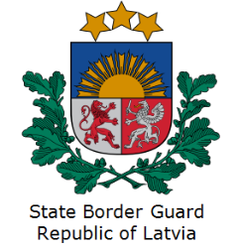 | This Programme is funded by the European Union  Delegation of the European Union to the Kyrgyz Republic  21 Erkindik Boulevard, Business Centre Orion, 5th floor  Bishkek, 720040, Kyrgyz Republic  Telephone: +996 312 26 10 00  Fax: +996 312 26 10 07  E-mail: delegation-kyrgyzstan@eeas.europa.eu  Website:http://eeas.europa.eu/delegations/  kyrgyzstan  Facebook:http://www.facebook.com/eudelkg | The European Union is made up of 28 Member States who have decided to gradually link together their know-how, resources and destinies. Together, during a period of enlargement of 60 years, they have built a zone of stability, democracy and sustainable development whilst maintaining cultural diversity, tolerance and individual freedoms. The European Union is committed to sharing its achievements and its values with countries and peoples beyond its borders.

