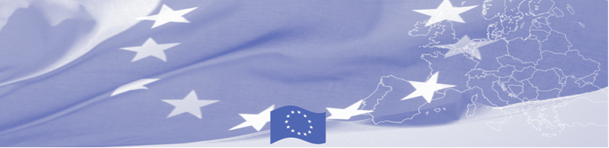
PRESS RELEASE

Principles of delegation of functions in border and customs control are being discussed in Almaty, Kazakhstan

Almaty, 11 February 2020

Regional workshop on enhancing interagency cooperation in the area delegation of functions in border and customs control starts in Almaty, Kazakhstan on 11 February within the framework of EU funded Border Management Programme in Central Asia (BOMCA). The event gathers 20 representatives from Border and Customs Services from Kazakhstan, Kyrgyzstan, Tajikistan, Turkmenistan and Uzbekistan.
Recently, in such EU countries as Finland, Estonia, Latvia and Lithuania, a method of delegating the functions between customs and border services at the first border control line is being actively developed. This method allows to accelerate the movement of passengers and goods across the border and to use more effectively resources of border agencies. Within this BOMCA organized workshop EU experts will present their experience in delegating border control functions at the checkpoint, thereby providing an opportunity to participant to get acquainted with this innovation and discuss its the benefits and risks.
In particular, attention will be paid to interagency cooperation, its main objectives and legal framework; synchronized control and delegation of functions / tasks of border and customs control at the checkpoint; cooperation in the field of information exchange and risk analysis. Based on Finland, Estonia and Lithuania best practices, practical examples of implementing this method, including analysis of the results will be presented to participants.
The first BOMCA operations in Central Asia began in 2003 and, since then, BOMCA has strengthened the partnership between Central Asian Governments in the field of border management. The European Union allocated a sum of EUR 40, 1 million to BOMCA for the period of 2003 – 2019, out of which EUR 6, 6 million were assigned to its 9th implementation phase (2015 - 2019).

For more information please contact Ms. Janna Tashieva, BOMCA Regional Communications Officer at janna.tashieva@icmpd.org

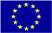  The Programme is imple-mented by the Consortium of partners led by the State Border Guard of the Republic of Latvia:  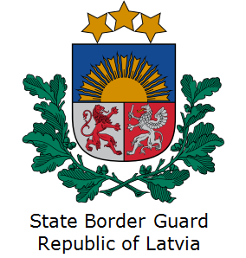 | This Programme is funded by the European Union  Delegation of the European Union to Kazakhstan  62, Kosmonavtov street, 4th floor  Astana, 010000, Republic of Kazakhstan  Telephone: + 7 7172 97 45 40, 97-11-48  Fax: + 7 7172 97 95 63  E-mail: Delegation-Kazakhstan@eeas.europa.eu  Website:http://eeas.europa.eu/delegations/Kazakhstan  Website: https://www.bomca-eu.org | The European Union is made up of 28 Member States who have decided to gradually link together their know-how, resources and destinies. Together, during a period of enlargement of 60 years, they have built a zone of stability, democracy and sustainable development whilst maintaining cultural diversity, tolerance and individual freedoms. The European Union is committed to sharing its achievements and its values with countries and peoples beyond its borders.

